Contents

Portfolio 1.1 -----------------------------------------------------------------------------------

Portfolio 1.2 -----------------------------------------------------------------------------------

Portfolio 1.3 -----------------------------------------------------------------------------------

Portfolio 1.4 -----------------------------------------------------------------------------------

Portfolio 1.5-----------------------------------------------------------------------------------

Portfolio 1.6 -----------------------------------------------------------------------------------

# **Portfolio 1.1**

**Project Proposal**

**Site Title**: House of Cards

**Developer and his role**:

The main aim of the developer is to design a website that fulfil all the requirements of House of Cards which give various information of cards such as data of postcards, greeting cards and playing cards and website should work any kind of web browser.

**Aim of the Project:**

The main of the project is to develop a website for The House of Cards which can be accessible for different kind of web browsers and easy user interface with all the required information of the House of cards in the website.

**Planning the website and structure:**

Components to be covered in the website:

* Title and logo on every page
* Design of the house of Cards in the home page .(Floor plan map)
* Easy navigation from page to page.
* Timings and contact details.
* Accessibility to any kind of web browsers.

**Site Content**:

The content in the website will have the collected data of different cards/pages available here and will have around 18 to 24 pages along with its description of the each page.

**Targeted audience and viewers:**

Our targeted audiences for the website are those have interested in knowing the business and available cards in the House of cards and for the people who likes to know details of different varieties of cards, location and timings of the house of cards.

**Design Considerations of application:**

* The navigation from page to page should be easy and should not take long time for loading the page.
* Should run in all the browsers.
* Should have accessibility features
* Basic HTML and CSS should be used for developing the website
* User interface should be easy to handle.

**Limiting factors:**

* Should not use any third party libraries for developing the website.
* Should not use any scripting.
* No tools must be used to automate the design process

**Portfolio 1.2:**

**Home page:**

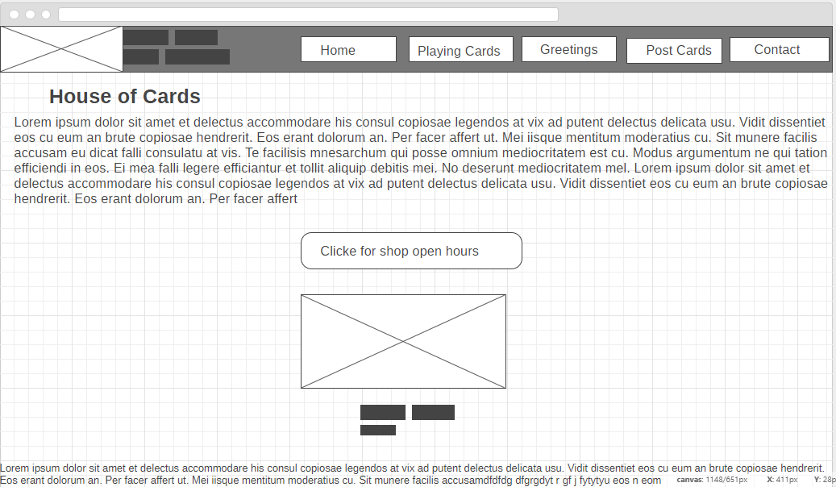

Figure: Home template design

**Individual Card menu Page:**

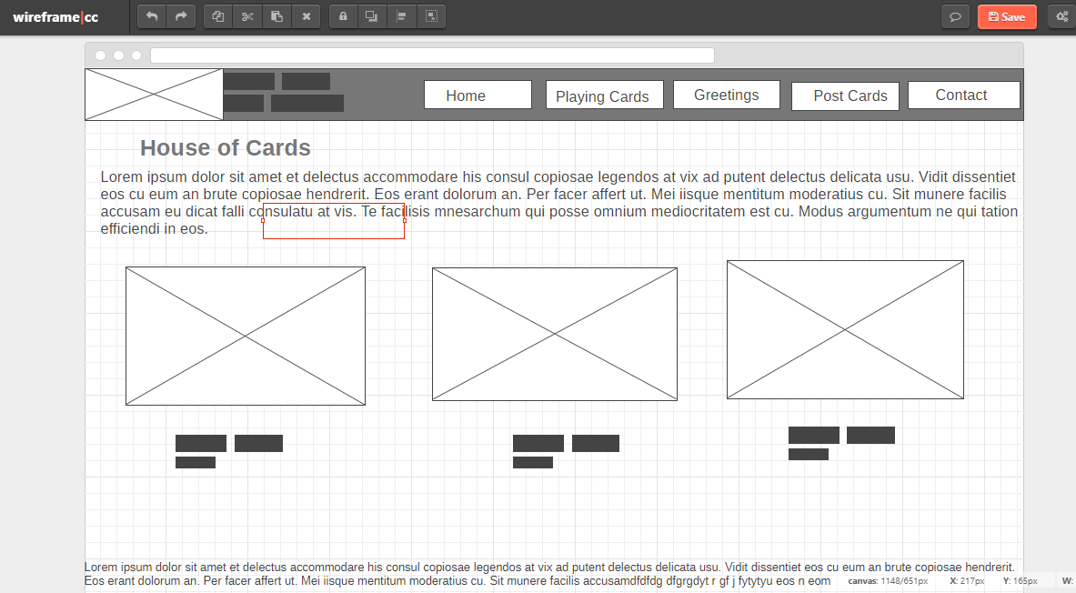

Opening Hours page (Time table):

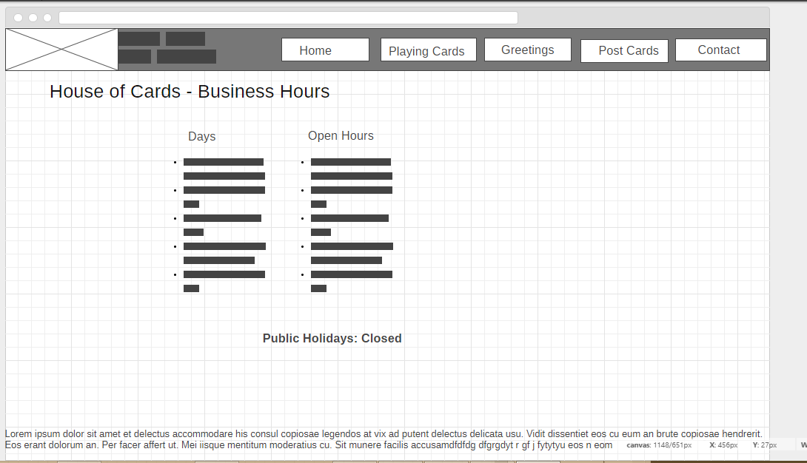

Figure: Individual pages

**Portfolio 1.3**

**Website Specifications:**

**Client**: House of Cards

**Specification**:

* The logo should be every page and must navigate to home page.
* Home page should have store floor plan and description of the house of cards.
* Navigation from page to page in the website should work properly.
* Business hours of the house cards should be placed and on clicking it should direct to another web page where the details of the opening hours are mentioned and displayed.
* Cards should be divided in way that it should redirect to different cards in the store and should be provided with as much as information possible to display on the website.
* No names can be edited and images should not be modified or edited.

**Success Measurement factors:**

* User interface should be easy.
* User should not be confused or lost while using the website particularly while navigating from page to page.
* Should satisfy the user with great user experience.
* This should increase the value of the business in terms of marketing and publicity.
* Provided information should reach to the targeted audience which should expand the business online also.

**Aim**:

The main aim of the house of Cards website should increase the business and must target the customer.

Technical Limitations for Design and Development:

1. Scripting should not be used here.
2. Should only use HTML and CSS for the design in the website.
3. No server or dynamic content must be displayed or rendered

**Flow Chart**

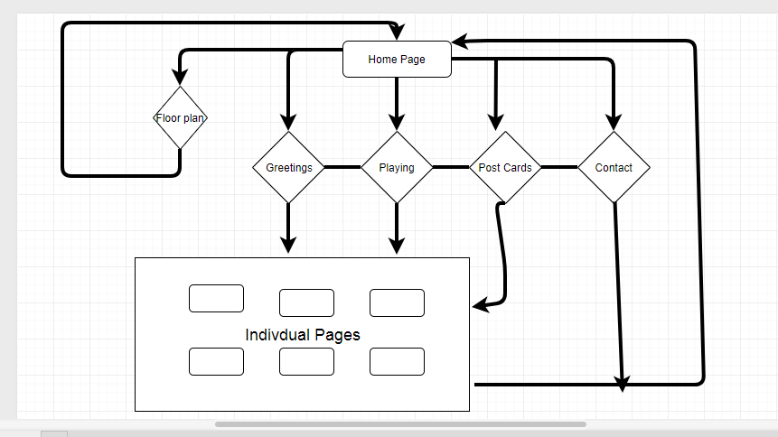

Figure: Flowchart

Application Flow:

1. From any page in the website, a user can navigate to home page by clicking on the logo.
2. Each and every page is connected through navigation bar.
3. Similar cards are written in the same name so browsing will easy for the user.
4. Floor map is well designed which will show clear picture of the store.
5. Users can also click on the floor map to navigate to the content page directly without the use of navigation bar

**Portfolio 1.4**

* Cascading style sheets are extensively used in designing the site, most of the styles are applied using classes and tags for global reference
* Very few styles’ are inline to override the default styles applied previously
* Best practices are used in writing css code, with elegant and neat combinations of pseudo and ids
* Various attributes like font-size, font-weight, colour, background, width, border have been modified to adjust the elements on the web page

Possible Class names that can be used in assigning to the elements are:

* Nav class for navigation
* Logo class for logo and name of the client/business
* Footer section as footer class
* Content class for image containers and so on..

Different levels in creating the document are:

* HTML document has a special structure called as Dom(Document Object Model) , that can be formed with html as tag, but it can have multiple tags enclosed in it to structure the level of document with siblings and parents, and children elements
* E.g.:

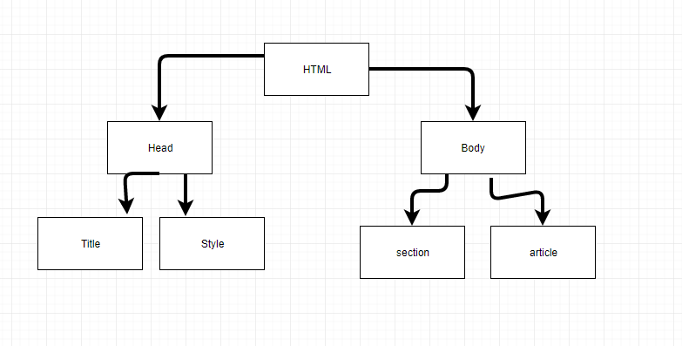

Figure: Sample HTML structure and levels

Html{

Head{

<navigation></navigation>

<link href></>

<tags>

}

Body{

<h1>

Name of the Heading

</h1>

<section>

</section>

<article>

<p>

{

“Random paragraph Content here”

}

</p>

</article>

Footer{

<p>

{

“Random Footer Content here”

}

</p>

}

}

}

**Portfolio 1.5:**

Type hierarchy of the website

* Type hierarchy is well designed to maintain the readability and accessibility of the content on the website

Type specification

1. Use of times new roman as font family
2. Font size as 16px
3. Font weight bold for headings and title
4. Colour as specified in the design
5. Extra 4px padding for best alignment for elements

* Default font is used for some paragraphs
* Three levels of headings are used out of 6, i.e. Is h1 to h3
* 2 different weights to be used, i.e. Bold and italic
* Text will be emphasizes using bold and italic text with 16 px font size
* Increase letter spacing to make the content more legible and readable
* Line height of 1.6 will be adjusted accordingly

**Portfolio 1.6**

* Box properties like border, padding, margins are used to align the items according to the design
* Without the box model, the content to be displayed would be not as intended
* Margins will be adjusted with percentages to have similar in all devices irrespective of the screen resolution
* Images, paragraphs, headings will be benefited by using the box model.

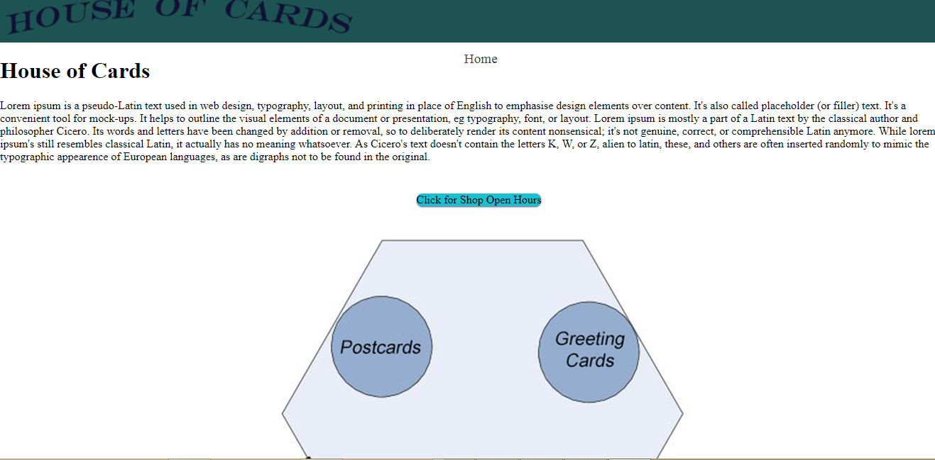

Figure: Sample image 1

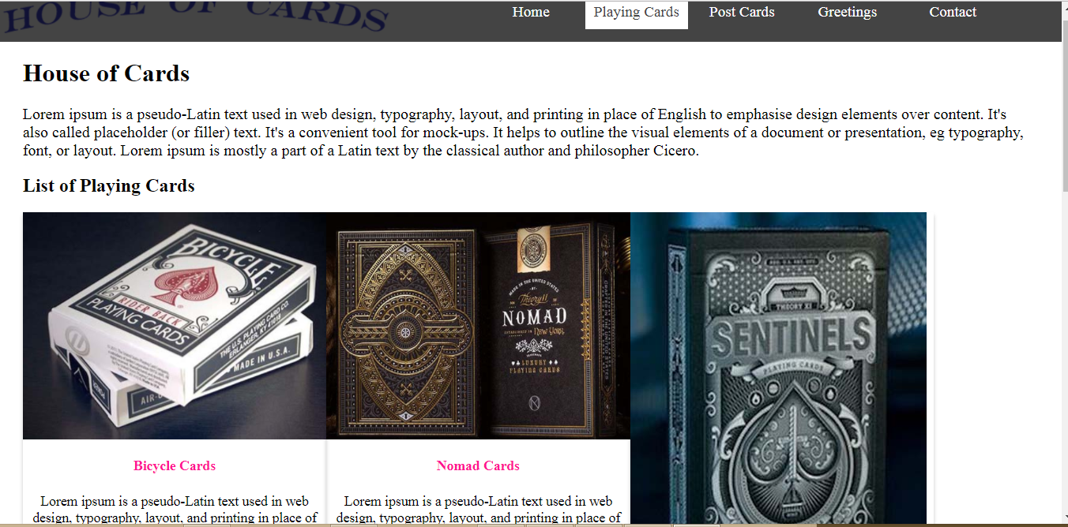

Figure: Sample image 2 without padding and margins

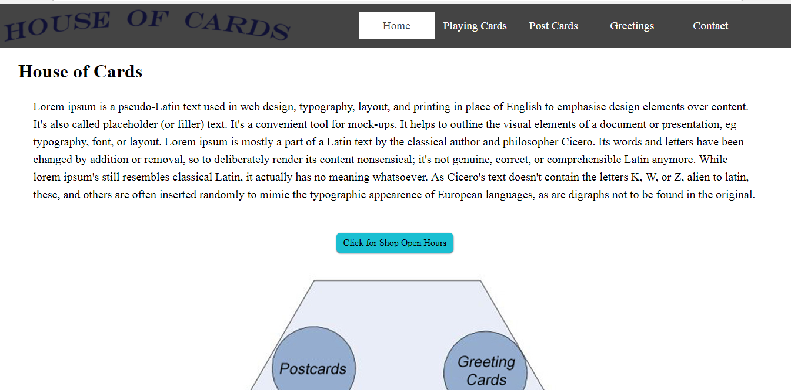

Figure: Box model sample